TITLE:
INTRODUCTION
In Southeast Alaska, a mosaic of glacial- snowmelt- and rainfed watersheds provides a variety of stream habitat available to salmon (Shoen, Shanley, Sergeant, …). As climate change brings warmer temperatures and alters precipitation patterns, the thermal conditions in streams are expected to change (Mauger, Lisi, Isaak). Depending on current conditions and sensitivity to change, the thermal conditions may become more hospitable to salmon in some watersheds, while others may transition to more marginal habitat, with episodically or chronically elevated temperatures. Projecting future stream temperatures is critical for informing conservation and restoration priorities and actions and adapting management strategies to promote local and regional resilience of salmon populations.
[Do we need a paragraph about stream temp effects on salmon/aquatic life and/or relevant temperature metrics/thresholds?]
Stream temperature is controlled by the temperature of water as it enters the watershed and subsequent net absorption of thermal and solar radiation (Johnson…, other budget studies). Glacial- and snowmelt runoff provide coldwater inputs relative to rain (Fellman, Edwards/Schoen…), while retentive surface features like lakes and wetlands increase water storage time and allow for absorption of more thermal and solar energy, increasing temperatures (citation). Past studies have demonstrated positive correlations between summer stream temperatures and lake cover, wetland cover, and drainage area, and negative correlations with elevation, latitude, slope, glacier, forest and riparian cover, and groundwater indicators like baseflow index and geology (e.g. Fellman, Winfree, Mauger, Lisi, Isaak et al., 2017).
Strong relationships often exist between air and water temperature despite the small role of conductive heat transfer from air to water relative to solar radiation in a stream’s heat budget (Johnson, Sinokrot and Stefan, 1993; Webb and Nobilis, 1997). As a result, air temperature has been used as a surrogate predictor for water temperature dynamics at annual to daily time scales (citations). The apparent sensitivity of water temperature to air temperature (i.e., increase in water temperature relative to increase in air temperature), has been positively correlated with watershed drainage area, and negatively correlated with latitude, slope, and elevation (e.g., Mauger, Winfree). These relationships are consistent with a watershed’s capacity to absorb solar and thermal energy and potential buffering effects of cold water inputs. [more in here about interannual sensitivity/variability being relevant for future projections, and cold water streams generally considered less sensitive for a variety of reasons – e.g. position as colder, headwater streams; less time for equilibrium with incoming radiation, more continuous coldwater inputs by GW throughout watersheds, etc. (Luce et al 20214) BUT lots of variability around this assumption].
Previous studies have projected future stream temperatures associated with increasing air temperatures using models based on current relationships with static watershed characteristics, applied uniform increases, or applied a sensitivity based on current stream temperatures, i.e. cold streams are assumed to warm less than already-warm streams (Mauger, Isaak). However, predicting future stream temperatures given future increases in air temperatures may be problematic if current relationships do not remain constant through time. For example, elevation and latitude are likely proxies for snowmelt contribution, which is a more mechanistically relevant variable, and one that is projected to decline dramatically in southeast Alaska (Littell et al., 2018, Lader et al., 20XX). Glacier loss is also expected to be extensive in southeast Alaska (Ziemen et al, 20XX) and should be accounted for in future stream temperature projections for the region.
In this study, we use stream temperature data from 69 watersheds across southeast Alaska to develop a predictive model for peak summer water temperatures. Importantly, this model includes variables that affect sensitivity and that can shift over time, rather than static proxy variables. We then apply this model to all coastal watersheds in the region, and project future changes under climate scenarios for 2050 and 2080 to provide insights into where thermal habitat may become more or less productive for salmon.
METHODS
Stream Temperature Data
Stream temperature data were obtained from 74 watersheds through the Southeast Alaska Stream Temperature Monitoring Network and from publicly available, quality-controlled sources, including the US Geological Survey, and the National Park Service. Network cooperators commit to following at least the minimum data collection standards laid out in Mauger et al. (2016) and use Onset HOBO ProV2, MX400, TidbiT v2, or similar loggers with precision greater than or equal to 0.2°C to collect hourly data. We used an automated quality control procedure to identify temperatures below 0°C (indicating freezing or exposure to air), large hourly changes in temperature (indicating potential exposure to air or tidal influence), and very high temperatures (indicating potential exposure to air). Data were visualized with nearby weather, tidal, and stream temperature data to assess validity, and these assessments, aided by field notes, were used to remove erroneous data. When two loggers were installed near each other in the same stream as duplicates, we averaged quality-controlled data for a single time series per site.
For analyses of peak summer temperatures, data coverage of June through August was examined. If less than 98% of the time was covered, data were visually examined to determine whether peak temperatures were highly likely to have been captured based on rising and falling temperature trends and comparisons to other years with data. This resulted in 74 sites with 374 total years of data, ranging from 2008 to 2022 (Figure X). For these sites, the mean weekly maximum temperature (MWMT), the highest rolling weekly average of daily maximums, was calculated for the period of June-August. Additional temperature metrics, such as number of days with temperatures exceeding 15°C and 18°C, and productive season length (defined as consecutive days with weekly average temperature > 4°C) were also calculated for site years with sufficient data.
Watershed Attributes
We quantified the following characteristics for the drainage area above each monitoring site: area, mean latitude, and mean longitude; mean elevation, slope, and percent facing north, south, east and west (DEM layers); percent glacier cover (Randall glacier layer 6.0); percent lake cover (SEAK Hydro); percent wetland cover (Freshwater emergent wetland + freshwater bryophyte FWS); percent of geology classed as unconsolidated surficial sediment (USGS); and average historical fraction of winter (October-March) precipitation as snow (SFEP) and snow-water equivalent (SWE) precipitation (Littell et al, 2018).
Most water temperature monitoring sites were not co-located with air temperature loggers, so rather than using hyper-local air temperature data to predict stream temperature, we used climate division-averaged seasonal weather data for the four climate divisions in Southeast Alaska to characterize the interannual weather variability. Yearly values of maximum June-August temperatures (JJA-Tmax) and June-August precipitation (JJA-pcp) were extracted from NOAA’s “Climate at a Glance” Divisional Time Series online (NOAA citation) for the relevant Alaska climate divisions and assigned to watersheds within those divisions (Table X).
Table X. Range in NOAA climate division-averaged precipitation and temperature values for years with monitoring data, and values applied to the “current” scenario for all coastal watersheds (average for 2008-2022).
NOAA Climate Division | Range for monitored site-years |  | Current Scenario Value
 | Precipitation (mm) | June-August Tmax (Tmax-JJA) (°C) | Precipitation (mm) | June-August Tmax (Tmax-JJA) (°C)
Northeast Gulf (9) | 16.9-44.8 | 10.89-15.00 | 33.94 | 12.86
North Panhandle (10) | 9.9-25.7 | 11.39-14.56 | 15.18 | 12.77
Central Panhandle (11) | 22.9-51.1 | 11.72-14.33 | 35.09 | 12.65
South Panhandle (12) | 15.0-41.0 | 13.00-16.56 | 25.94 | 15.08

Because streams are monitored by multiple entities with their own monitoring goals, the sites with data that are available are not statistically representative of stream types (based on any number of qualities) across southeast Alaska. However, they do encompass a wide range of sizes, various land cover types, and rain-vs snow-dominated hydrology, and glacier cover (Table X., Supplemental Figure X)
Table X. Distribution of watershed attributes for the model training set and all coastal watersheds.
 |  | Min. | Q1 | Median | Mean | Q3 | Max
Area (km²) | Monitored | 0.06 | 11.9 | 30.8 | 61.1 | 74.6 | 460
 | Coastal | 2.101 | 5.392 | 9.544 | 25.254 | 21.438 | 909.964
Glacier (%) | Monitored | 0 | 0 | 0 | 3.1 | 0.2 | 40.3
 | Coastal | 0 | 0 | 0 | 2.783 | 0 | 69.809
Lake (%) | Monitored | 0 | 0.1 | 0.5 | 1.9 | 1.8 | 13.6
 | Coastal | 0 | 0 | 0.2011 | 1.6548 | 1.7118 | 26.1653
SWE (mm) | Monitored | 337 | 554 | 800 | 815 | 1054 | 1609
 | Coastal | 140.7 | 480.3 | 683.4 | 807.3 | 1009.8 | 3244
SFEP | Monitored | 20.8 | 34.5 | 38.9 | 43.4 | 49.1 | 80.0
 | Coastal | 10.79 | 25 | 33.43 | 36.1 | 44.24 | 83.53

Modeling Peak Summer Water Temperature
Multiple linear regression was used to model MWMT using predictor variables with hypothesized mechanistic relationships to stream temperature. Static predictors (and the hypothesized relationship to MWMT) included watershed area (+), watershed slope (-), percent wetland cover (+), percent glacier cover (-), presence of unconsolidated sediment (-), presence of karst (-), SFEP (-) and SWE (-), and mean elevation (-). Climate variables that changed annually included JJA-Tmax (+), and JJA-pcp (-).
Several watershed attributes were adjusted to better reflect mechanistic relationships in a linear model. Watershed area was adjusted downward by subtracting the glacier-covered area, which is not contributing significantly to (liquid) water residence time or warming by solar or thermal radiation. Additionally, previous research showed significant effects of glacial meltwater on summer stream temperatures, but the buffering effects leveled off somewhere between 30 and 50% glacial cover (Fellman et al, 2014). To account for this in a linear model, we capped effective glacial cover at 40%. Similarly, exploratory nonlinear modeling indicated a threshold effect of lake coverage on MWMT at around 6%, so this value was also capped for linear modeling purposes.
JJA-Tmax was allowed to interact with watershed characteristics to account for their effect on sensitivity of water temperature to air temperature. For example, glacier and snowmelt can buffer water temperatures in response to rising air temperatures (Fellman, others), while larger watershed area can increase sensitivity by increasing water residence time and solar and thermal radiation exposure (Mauger, Winfree, Isaak).
The most parsimonious model was identified using stepwise model selection based on Akaike Information Criterion (AIC) (stepAIC from MASS, Venables and Ripley, 2002). Before selecting a final model, the relationships between predictor variables, including any interaction effects, and predicted MWMT were examined and compared to their hypothesized effects to ensure nonsensical relationships were not included. Predictors with counterintuitive relationships (or interaction effects) were removed (or the potential for an interaction effect was eliminated) from the original model, and model selection using stepwise AIC was repeated. Additionally, several sites were ultimately excluded from the training set for the model because summer temperatures were so poorly predicted due to known or unknown drivers, and they were having a strong effect on model results. These included two groundwater-dominated streams near Klukwan (Clear and Herman), two streams in the Yakutat Forelands (Echo and Miller), where watershed delineation is problematic, and the lower Kelsall, because most of its drainage area was not covered by US data layers (wetland, snow).
Predicting summer water temperatures in unmonitored coastal watershed outlets
Coastal watersheds (drainages with a single stream outlet to the coast) were identified from Yakutat Bay in the north to the southern extent of the southeast Alaska panhandle. Large transboundary watersheds were excluded, but tributary sub-basins inside the Alaska border that drain to transboundary rivers were included (Figure X). Watersheds were obtained from the USGS Watershed Boundary Dataset down to the Hydrologic Unit 14 level, and a recent coastal mapping study Biles et al (2016). Land cover, geophysical, and climate characteristics were calculated for these watersheds as for the monitored watersheds, and the regression model for MWMT was applied to these watersheds to predict stream temperature at the outlets. The average of Tmax-JJA and pcp-JJA for 2008-2022 for each climate division were used in the “current” scenario (Table X).
Projected water temperatures for 2050 and 2080
MWMT was predicted for 2050 and 2080 for monitored and unmonitored watersheds, based on projected changes in JJA-Tmax, SWE, and glacier cover. JJA-Tmax was adjusted upward from the average of 2008-2022 for each climate division by 3°C for 2050 and 5°C for 2080, based on projected future increases in average June, July, and August temperatures for communities in southeast Alaska (RCP 8.5, SNAP community data citation). SWE values for 2050 and 2080 under RCP 8.5 were obtained from Littell et al. (2018). Projections for glacier area loss are not available for southeast Alaska, so glacial volume projections under a medium emissions scenario (RCP 6.0) for the Juneau Icefield were used as a proxy (25% loss by 2050, and 46% loss by 2080) (Ziemen et al., 2016). These estimates are highly uncertain and likely are underestimates for small glaciers not associated with larger icefields, but they represent near-certain downward trends. For both scenarios, JJA-pcp was left unchanged from the current scenario, as the direction and magnitude of change in summer precipitation is uncertain and expected to be small for southeast Alaska (Lader et al, 2020).
Water temperature sensitivity to JJA-Tmax was calculated for each watershed at each scenario (current, 2050, 2080) by comparing the predicted MWMT to MWMT when JJA-Tmax is further increased by 1°C. This sensitivity indicates the potential for year-to-year variability in water temperatures associated with interannual variability in summer air temperatures.

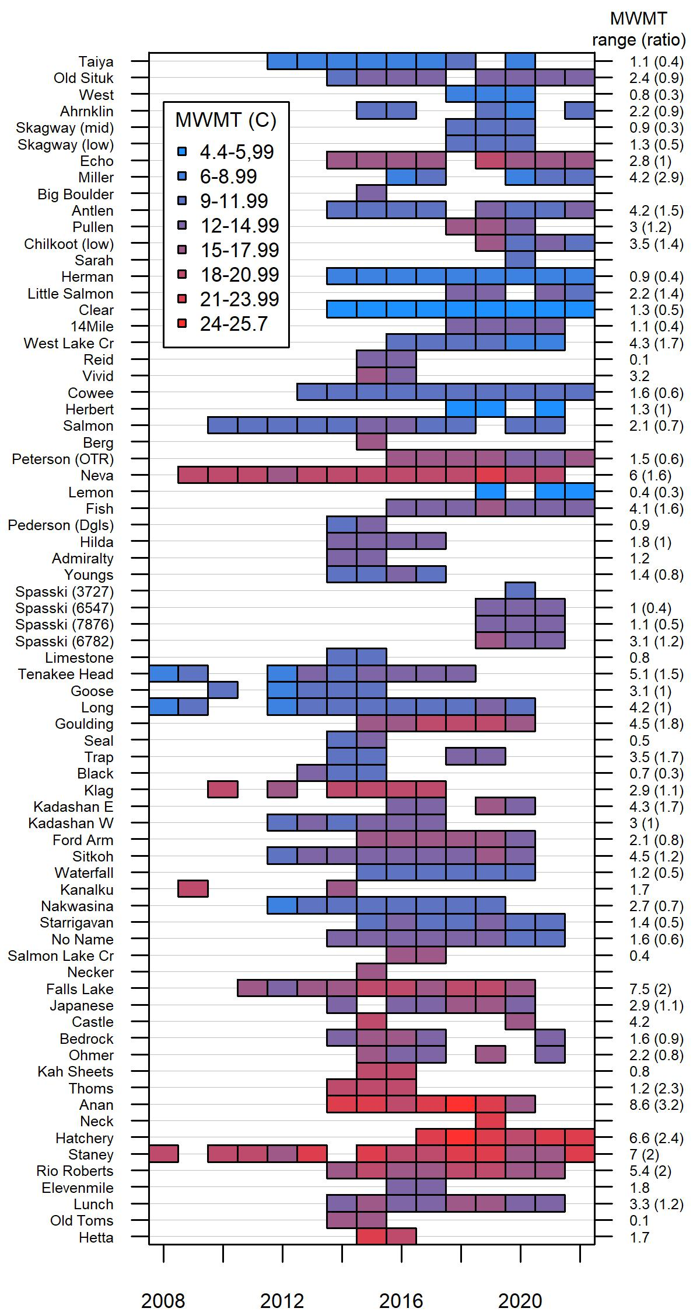

Figure X. MWMT for each site and year. Sites are plotted north (top) to south (bottom) on the y-axis. The range of MWMT values observed for each site (and ratio of range in MWMT to range in Tmax-JJA) are shown on the right.
RESULTS
Stream temperature variability across sites and years
Across all 323 site-years, MWMT varied from 4.4 to 25.7 °C (Figure X). Lower temperatures were more common in streams farther north, with glacial inputs, and larger average winter snowfall. Within sites, MWMT varied very little across monitored years (minimum range 0.1 °C) in some sites compared to others (maximum range 8.6 °C). However, these ranges are not directly comparable across sites since the years with available data differ, and summer temperatures (Tmax-JJA) varied from 10.9 to 16.6°C across site-years. A more comparable measure of variability is the range in MWMT relative to the range in JJA-Tmax experienced by a site across monitored years. For sites with three or more years of data, this ratio ranged from 0.3 in several glaciated watersheds to 3.2 in Anan, a relatively large watershed with high lake and wetland cover. The middle 50th percentile of sites had ratios between 0.6 and 1.5.
The multiple regression model with meaningful relationships between predictor variables and MWMT and the lowest AIC explained 78% of the variability in MWMT across all site-years and included watershed area, JJA-Tmax, lake cover, SWE, JJA-pcp, glacier cover, presence of unconsolidated surficial geology, and the interaction terms between JJA-Tmax and JJA-pcp, lake cover, glacier cover, and SWE (Table X). The interaction terms result in a smaller effect of JJA-Tmax on MWMT with increasing glacier cover, SWE and JJA-pcp. As lake cover increases, the relationship between JJA-Tmax becomes less steep, but the intercept is higher, resulting in an overall increase in MWMT with increasing lake cover. These interaction effects are displayed graphically in the Supplemental Material.
Table X. MWMT model based on 339 site years for 69 sites. (F-statistic: 108.6 on 11 and 327 DF, p-value: < 2.2e-16, adjusted r2 = 0.78)
Parameter | Units/Notes | Estimate | p-value | Variable Importance
(Intercept) |  | -1.506E+01 | 0.0038
Glacier cover | %, up to 40 | 2.304E-01 | 0.2914 | 3.1
Tmax-JJA | °C | 2.286E+00 | 0.0000 | 18.2
Lake cover | %, up to 6 | 1.877E+00 | 0.0003 | 10.9
SWE | mm, up to 1200 | 3.160E-03 | 0.5115 | 1.9
pcp-JJA | mm | 3.499E-01 | 0.0056 | 8.2
Area | ln(glacier-free area(km²)) | 2.428E-01 | <0.0001 | 21.0
Unconsolidated geology | Presence(1)/Absence(0) | -9.557E-01 | 0.0001 | 12.1
Glacier cover:Tmax-JJA |  | -3.143E-02 | 0.0552 | 5.7
Lake cover:Tmax-JJA |  | -7.342E-02 | 0.0514 | 5.8
SWE:Tmax-JJA |  | -6.099E-04 | 0.0898 | 5.0
pcp_JJA:Tmax-JJA |  | -2.522E-02 | 0.0069 | 8.1

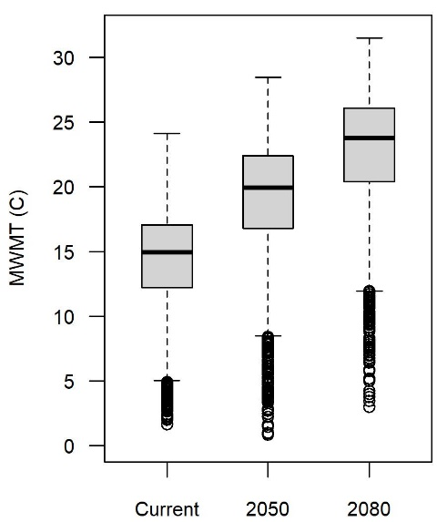 | 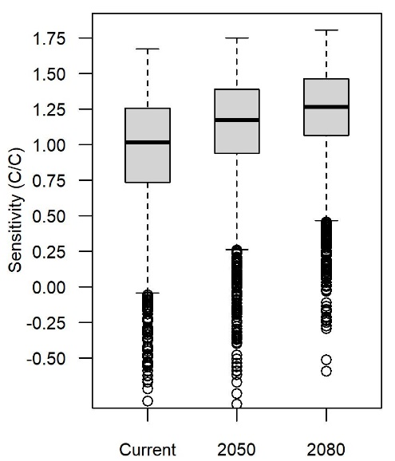
Figure X. Distribution of current and projected MWMT for coastal watersheds in SEAK (left) and interannual sensitivity of stream temperature to air temperature (ΔMWMT°C/ΔTmax-JJA°C).
Predictions for coastal watersheds
Predictions for current MWMT for all coastal watersheds ranged from 1.7 to 24.1°C, with a median value of 15.0°C. The warmest temperatures are predicted for watersheds in southern southeast Alaska, which lack glaciers and have much less snowfall than watersheds farther north (Figure X). Median values for MWMT increased by 4.9°C from the current scenario to 19.9°C the 2050 scenario, and by 8.8°C from the current to 23.8°C the 2080 scenario (Figure X boxplots). The largest increases in temperature are projected for sites with the lowest initial and projected SWE (< 500 mm).
The watersheds with the greatest modeled interannual sensitivity to air temperature (ΔMWMT°C/ ΔTmax-JJA°C) are those with low snowpack, less lake cover, and lacking glaciers or a geological indicator of groundwater inputs. Again, these sites are more common in southern southeast Alaska, but sensitive (i.e., C/C > 1.25) are found throughout the region (Figure X). The median sensitivity increased from 1.01 in the current scenario to 1.17 in 2050 and 1.26 in 2080 (Figure X boxplots).

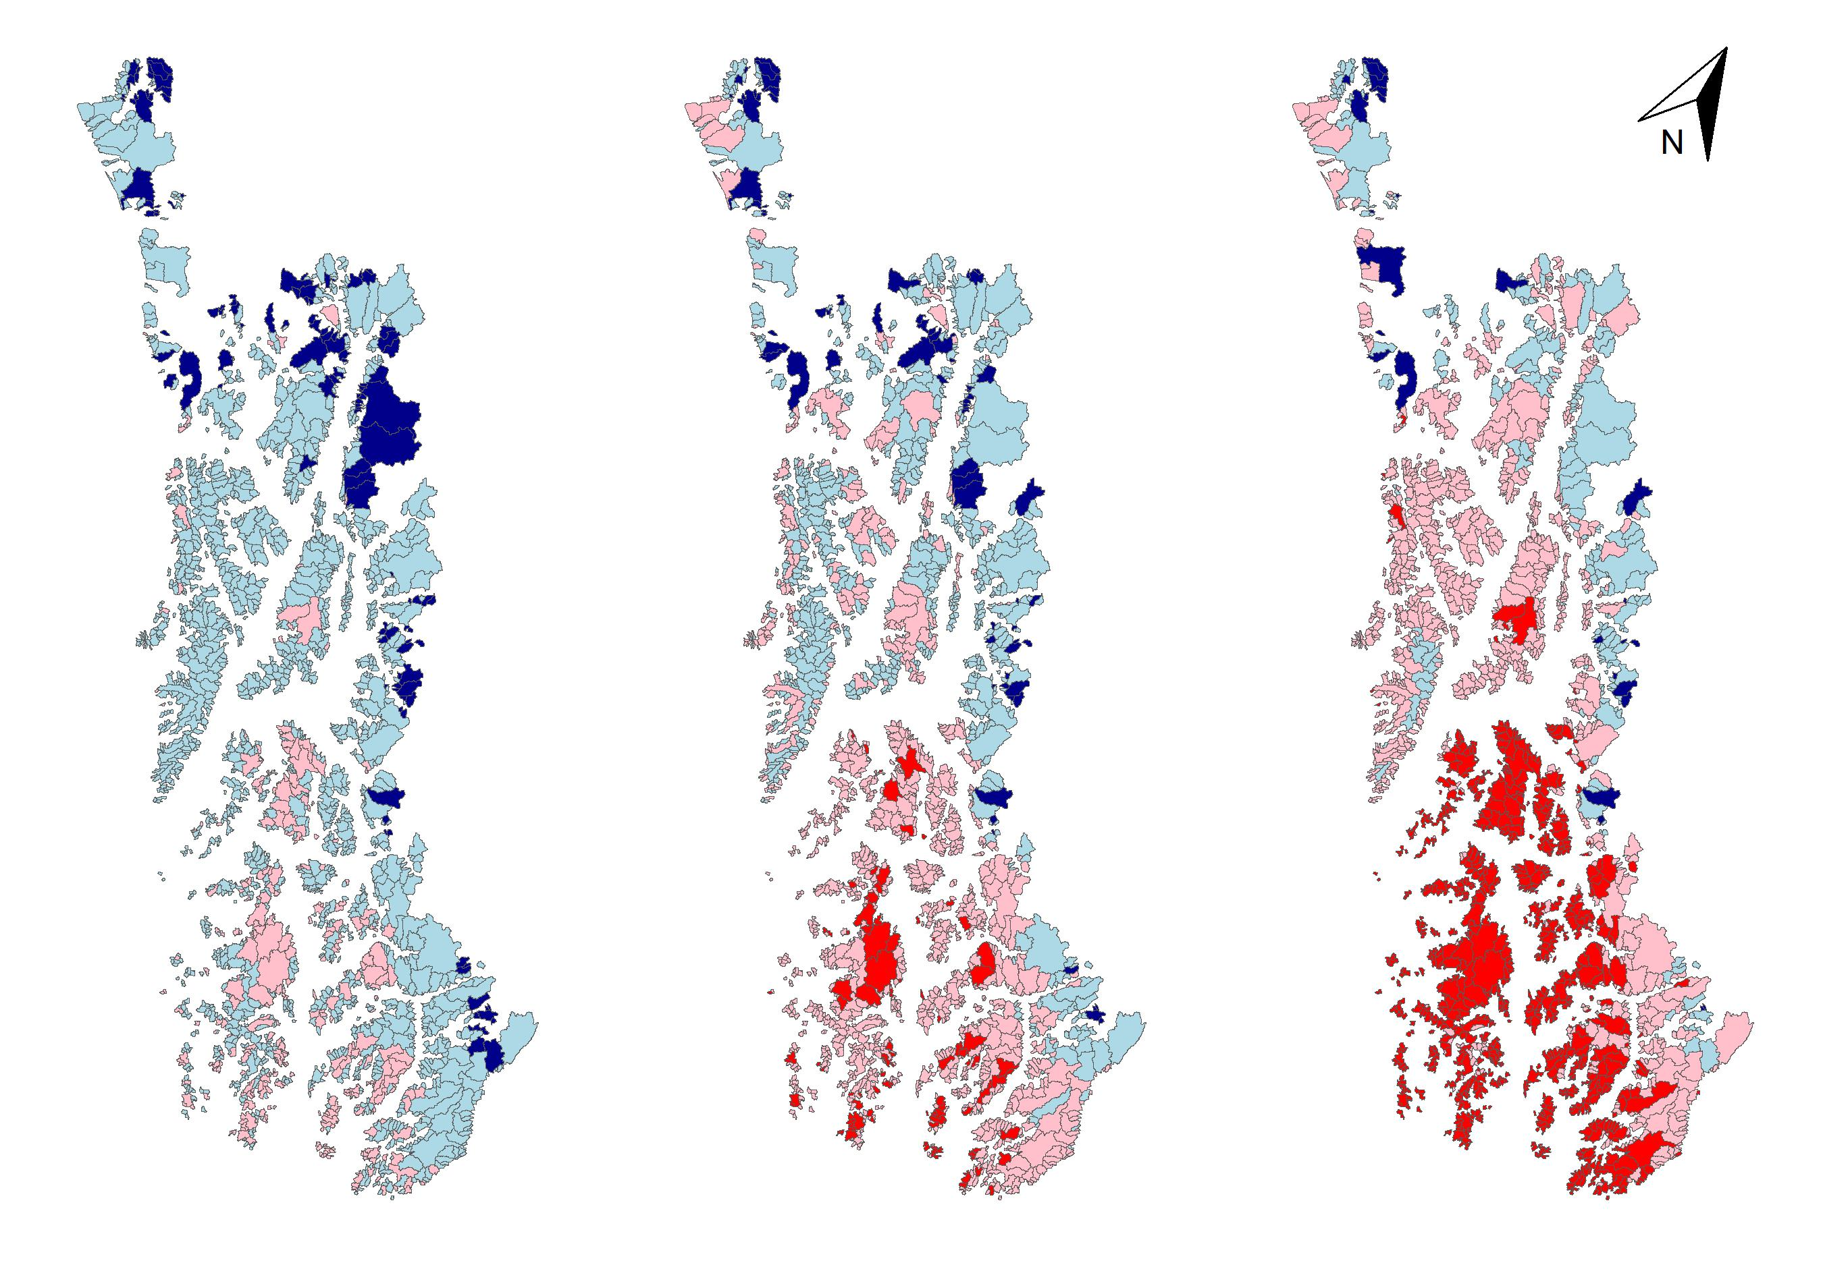
Figure X. Predicted MWMT for all coastal watersheds for current (left), 2050 (center), and 2080 (right) scenarios. Will add a legend, but dark blue < 8C, light blue <18C, light pink < 25C, red > 25C.
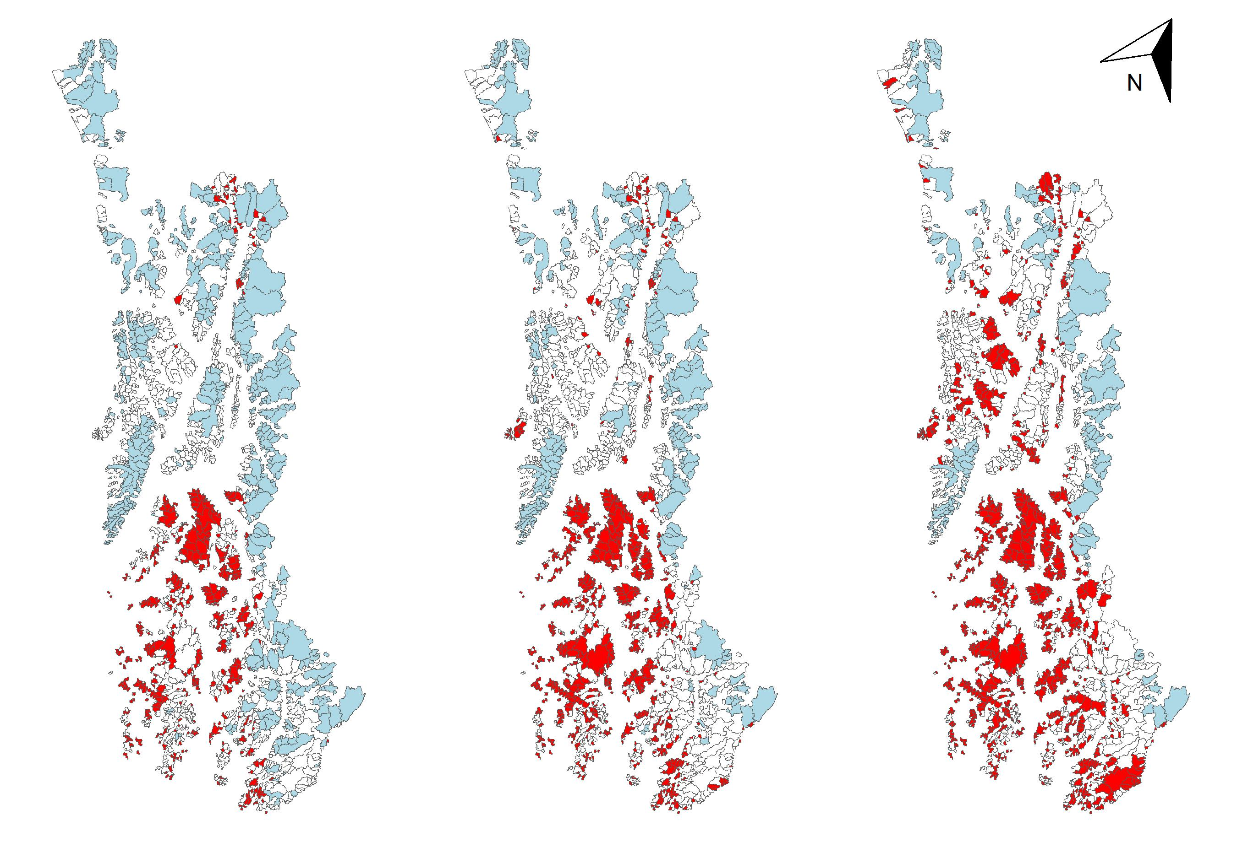
Figure X. Stream sensitivity to air temperature for current (left), 2050 (center), and 2080 (right) scenarios. Will add legend - blue > 0.75, white > 1.25, red < 1.81

DISCUSSION – potential points
- Observed stream temperatures, in relation to salmon thermal thresholds
  - Most in productive range; some had excursions above (>18) and in one instance, into fairly stressful conditions > 25.
  - Glacierized streams (and some heavily influenced by groundwater) are very cold – may not be the most productive places year-round, but provide important refugia at certain times of the year (Bellmore), and even diurnally when in close proximity to warmer areas (Armstrong…)
- Stream predictors relative to other studies
  - Not surprisingly, similar variables are important predictors – area, lake, GW
  - Here we use historical winter snowfall instead of elevation&latitude; Elevation and latitude explain 97% of fraction of winter precip as snow; 37% of winter SWE amount (some areas are drier than others). SWE can be projected into the future…
  - Effects of lakes – warming, but not sensitivity – maybe has to do with thermal inertia in system – not as “thermally flashy”? Is it worth going down this rabbit hole? The modeled pattern was what we saw for e.g. Fish Creek vs Peterson Creek.
- Model performance
  - MLR Model performed relatively well, but residuals ranged from -4.9 to 4.9, with the middle 50% between -1.2 and 1.2.
  - Some sites were consistently over-or under predicted. Sites that were consistently under predicted by > 2.5 – SalmonLake Creek, 14Mile, Hilda, Ford Arm, Staney; consistently over by >2.5 for Salmon, Nakwasina, Antlen, 11Mile. There wasn’t a clear spatial distribution of mean residuals across the region, or within climate divisions. Likely locally important factors like groundwater, riparian shading, etc. that were not captured in the model contributed to error.
  - Sites with more years of data had a wider range of residuals;
  - Within sites, lowest lows and highest highs were sometimes missed; weren’t able to factor in things like flash droughts, interannual variability in snowpack, etc. that also play a role, which are likely more important in some locations than others. (e.g. Nakwasina MWMT is strongly predicted by average snowpack on April 1 at 3 SNOTEL sites), less closely related to temperature. Sites with the widest range in residuals with extremes that weren’t well predicted – Falls Lake, Anan, are likely in the “transition” (snow-rain) phase, with relatively high average snowfall in the winter (SWE 840-1100), but lower fraction of winter precipitation as snow (35-37%). Interannual variability in snowpack may have a disproportionate effect on summer stream temperatures in watersheds with the potential for a lot of snow or a lot of rain, depending on how cold the winter is.
  - Importantly – groundwater inputs can strongly control stream temperatures (e.g. Clear, Herman), and these areas are difficult to identify a priori, although geology indicators provided a rough estimate. Can be very localized, and not necessarily related to the total amount of that type of surficial geology in a watershed.
- Southeast Alaska-wide projections
  - Reasonable range of predictions (~2-24C) for current MWMT. Stream temperatures in this region currently support large salmon runs, although some streams exhibit below-optimal temperatures, while others reach stressful temperatures.
  - Air temperature increases of 3 and 5 C relate to median streamwater increases of 5 and 8 C, despite median sensitivity of ~ 1.2. This is due to loss of snowpack and glaciers that buffer stream temperatures in the summer in many watersheds in the region. Higher temperatures on average overall… Temperatures in some watersheds are likely to shift to more optimal conditions.
  - By 2080 under high emissions scenario, majority of watersheds have MWMT above 23, and 75% have MWMT above 20C – these are pretty stressful conditions for spawning and migrating salmon, and the timing relative to warmest periods will be important. Will drastically increase risk for hypoxia (Sergeant 2023).
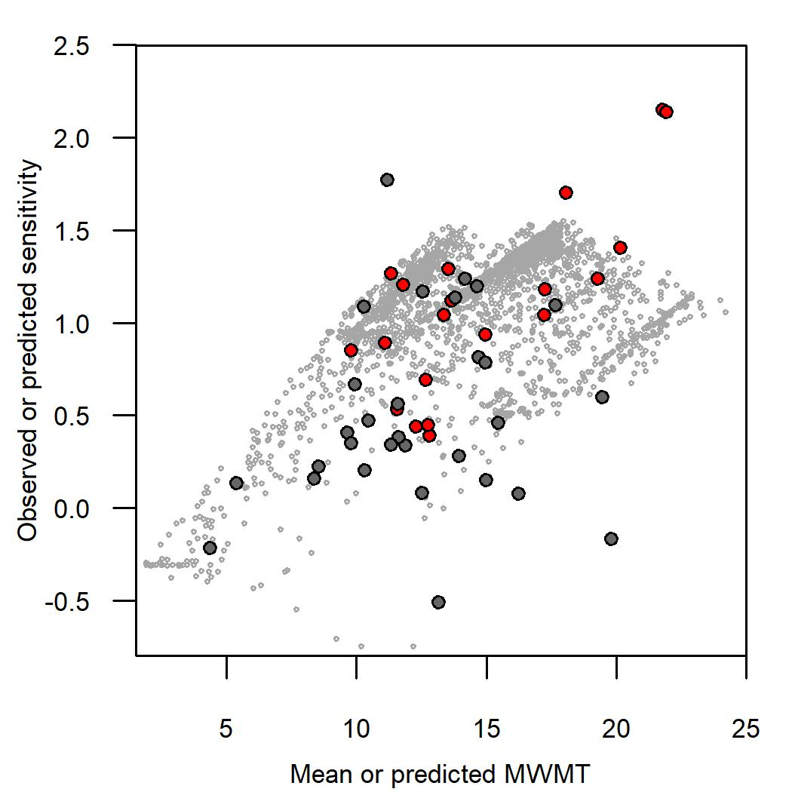
Figure X. Interannual sensitivity of MWMT to JJA-Tmax. Small gray points are modeled values for all coastal watersheds (current conditions). Large points are monitored systems, and observed sensitivity is the slope of the regression between MWMT vs JJA-Tmax, with red indicating a significant relationship (p < 0.05), for sites with n ≥ 3.
- Sensitivity
  - Some higher than 1; observed in other studies.
  - Not super closely related to current temps: The very coldest are the least sensitive (highly glacierized streams), but the warmest aren’t necessarily the most sensitive.
- Implications
  - MWMT represents a peak temperature period at the watershed outlet/monitoring location. High temperatures at watershed outlets may be most significant for pink and chum if it coincides with in-migration, and may represent a migration barrier for all species. May see continued trends towards later runs.
  - Can’t forget that there’s likely a lot of cooler habitat upstream
  - Although this model is for MWMT/peak temperatures, and therefore a potentially episodic stressor, Elevated MWMT is also related to more chronically stressful temperatures (Figure X). In monitoring sites with MWMT above 15 and 18, the number of days with temperatures above those increases dramatically with small increases in MWMT. Average temperatures are likely to head in the same direction as MWMT, with chronic thermal stress also increasing.
  - Mgmnt implications –
    - Important that weirs not hold fish up in warm water – find alternative technology?
    - Keep as much local cooling/prevent warming through riparian shading, groundwater connectivity, etc. in place as possible, although this is probably more effective in smaller streams where you can affect the heat budget more (citations?).
    - Hatchery release sites in relation to sites most at risk of hypoxia
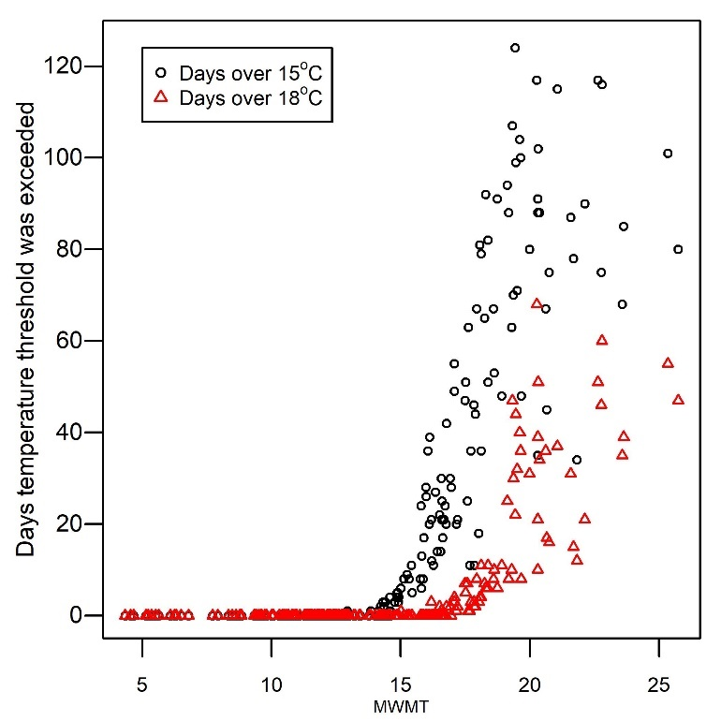

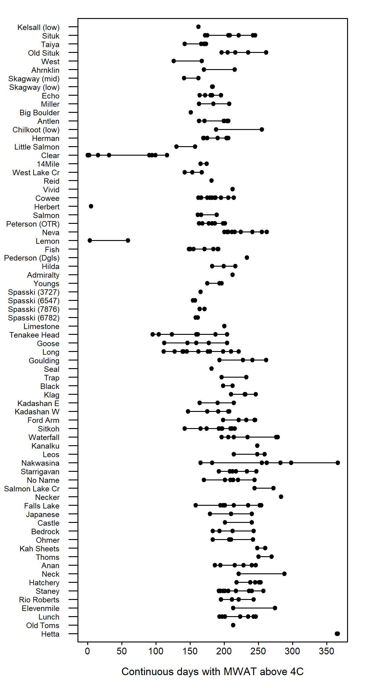

CONCLUSION
CITATIONS
Biles et al 2016
Isaak, D. J., Wenger, S. J., Peterson, E. E., Ver Hoef, J. M., Nagel, D. E., Luce, C. H.,. . . Parkes-Payne, S. (2017). The NorWeST summer stream temperature model and scenarios for the western U.S.: A crowd-sourced database and new geospatial tools foster a user community and predict broad climate warming of rivers and streams. Water Resources Research, 53. https://doi.org/ 10.1002/2017WR020969.
Lader, R., Bidlack, A., Walsh, J. E., Bhatt, U. S., & Bieniek, P. A. (2020). Dynamical Downscaling for Southeast Alaska: Historical Climate and Future Projections. Journal of Applied Meteorology and Climatology, 59(10), 1607-1623. https://doi.org/10.1175/JAMC-D-20-0076.1
Mauger 2016, Protocols for Stream Temp
NOAA Climate at a Glance Divisional Time Series https://www.ncei.noaa.gov/access/monitoring/climate-at-a-glance/divisional/time-series
Venables WN, Ripley BD (2002). Modern Applied Statistics with S, Fourth edition. Springer, New York. ISBN 0-387-95457-0, https://www.stats.ox.ac.uk/pub/MASS4/.
Yakutat area geology: https://gis.data.alaska.gov/datasets/seakgis::geology-labeled/explore?location=59.221734%2C-139.636479%2C7.00
https://gis.data.alaska.gov/datasets/seakgis::geology-labeled/explore?location=59.221734%2C-139.636479%2C7.00iment,

Geology https://pubs.usgs.gov/publication/sim3340

Supplemental
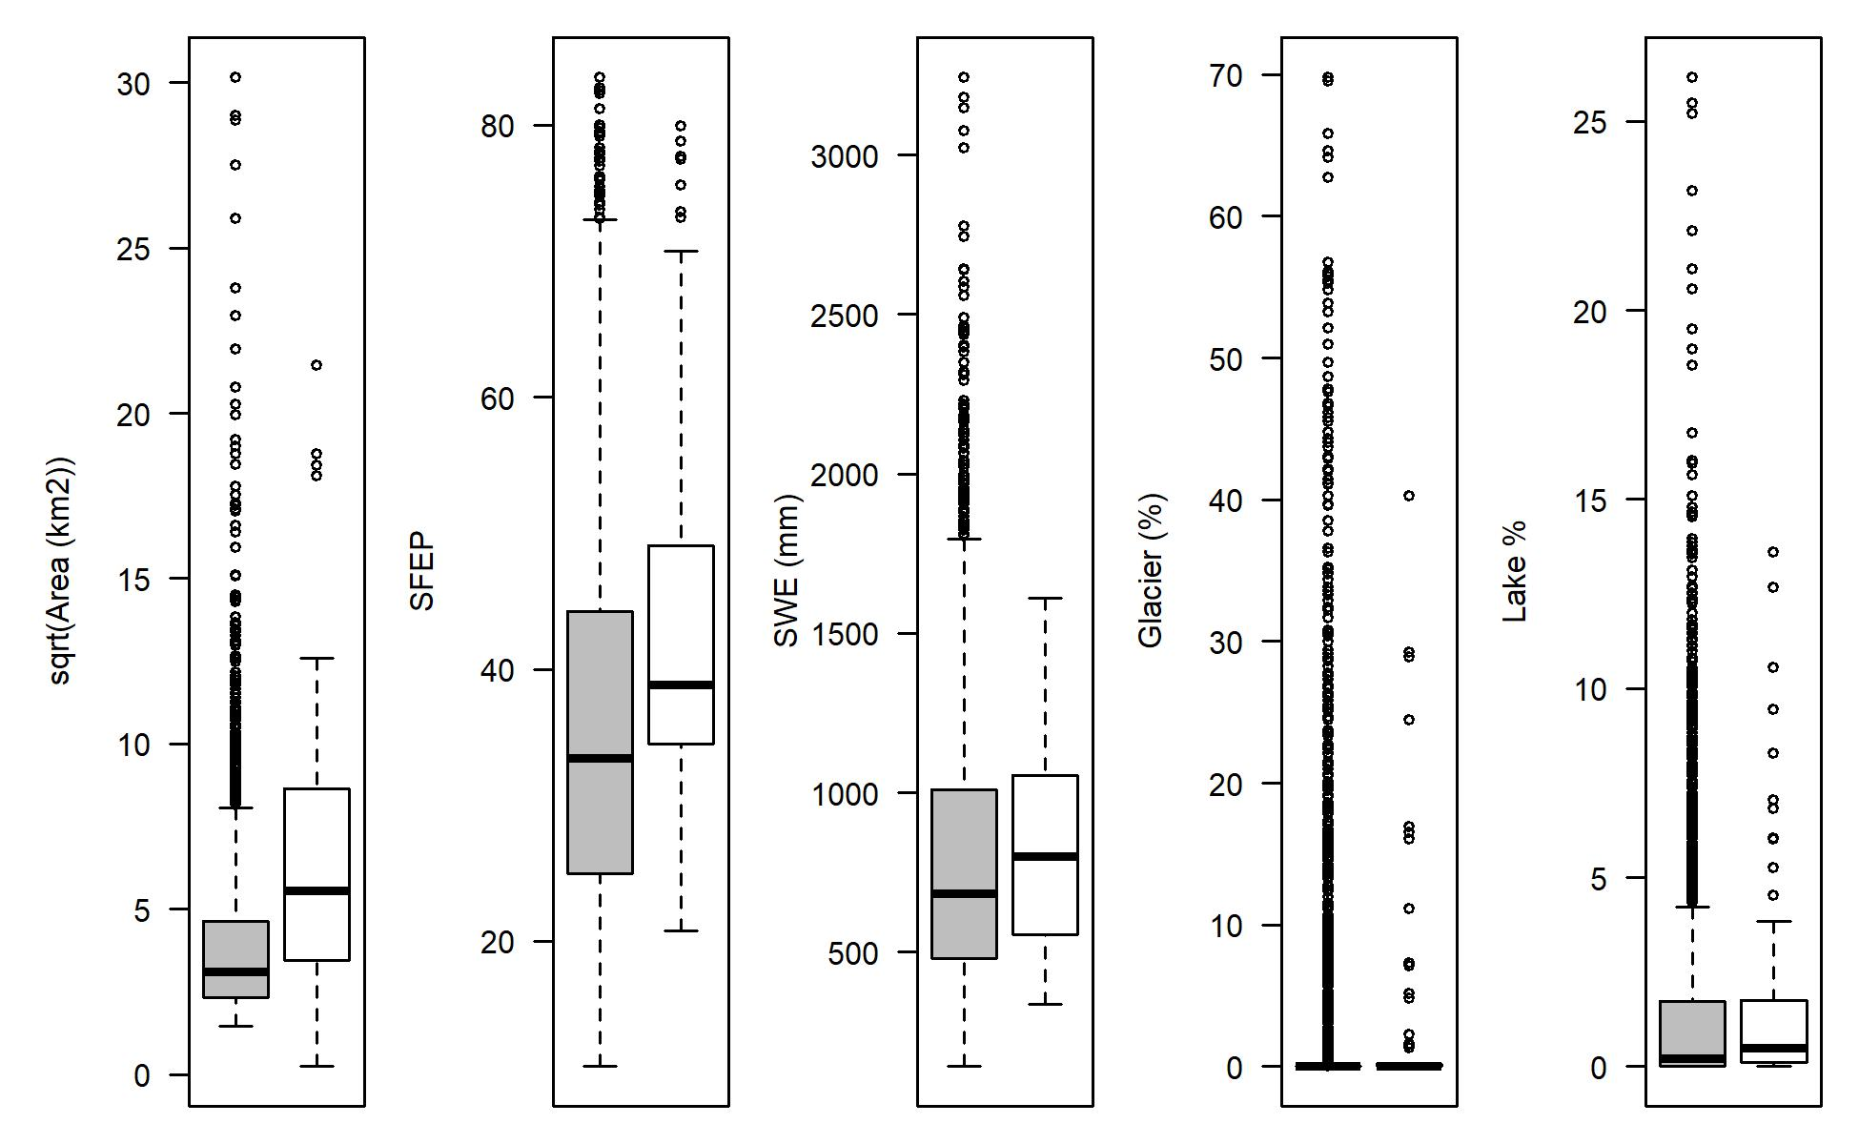
Figure X. Comparison of watershed attributes for all coastal watersheds (gray) and monitored watersheds used in the model training set (white).

MODEL DETAILS
Call:
lm(formula = MWMT ~ GlacierCover + tmax_JJA + Lake.Percent +
SWEHist_MEAN + pcp_JJA + AREASQKM + Unconsolidated_Present +
GlacierCover:tmax_JJA + tmax_JJA:Lake.Percent + tmax_JJA:SWEHist_MEAN +
tmax_JJA:pcp_JJA, data = data.lm.gw)

Residuals:
Min 1Q Median 3Q Max
-4.9419 -1.2258 0.0069 1.1702 4.9140

Coefficients:
Estimate Std. Error t value Pr(>|t|)
(Intercept) -1.506e+01 5.172e+00 -2.913 0.003830 **
GlacierCover 2.304e-01 2.180e-01 1.057 0.291367
tmax_JJA 2.286e+00 3.725e-01 6.137 2.43e-09 ***
Lake.Percent 1.877e+00 5.085e-01 3.691 0.000262 ***
SWEHist_MEAN 3.160e-03 4.808e-03 0.657 0.511458
pcp_JJA 3.499e-01 1.255e-01 2.787 0.005635 **
AREASQKM 2.428e-01 3.424e-02 7.092 8.22e-12 ***
Unconsolidated_Present -9.557e-01 2.341e-01 -4.082 5.62e-05 ***
GlacierCover:tmax_JJA -3.143e-02 1.634e-02 -1.924 0.055237 .
tmax_JJA:Lake.Percent -7.342e-02 3.755e-02 -1.955 0.051443 .
tmax_JJA:SWEHist_MEAN -6.099e-04 3.584e-04 -1.701 0.089816 .
tmax_JJA:pcp_JJA -2.522e-02 9.268e-03 -2.721 0.006850 **
---
Signif. codes: 0 ‘***’ 0.001 ‘**’ 0.01 ‘*’ 0.05 ‘.’ 0.1 ‘ ’ 1

Residual standard error: 1.857 on 327 degrees of freedom
Multiple R-squared: 0.7851, Adjusted R-squared: 0.7779
F-statistic: 108.6 on 11 and 327 DF, p-value: < 2.2e-16
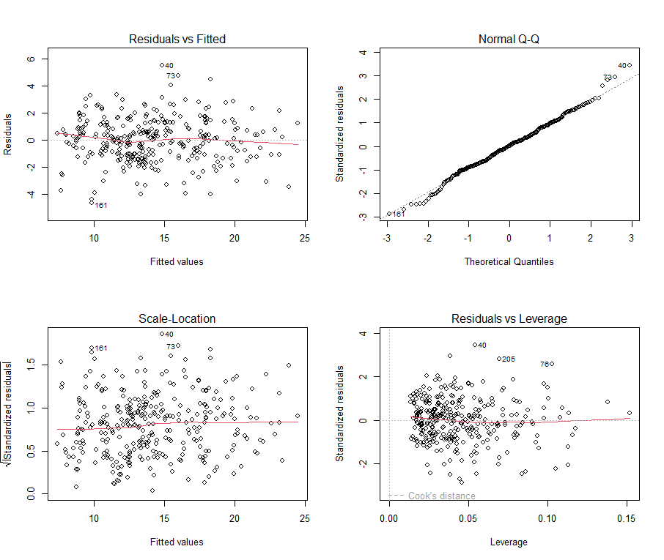
Figure S.X. Diagnostic plots for multiple linear regression model for MWMT.

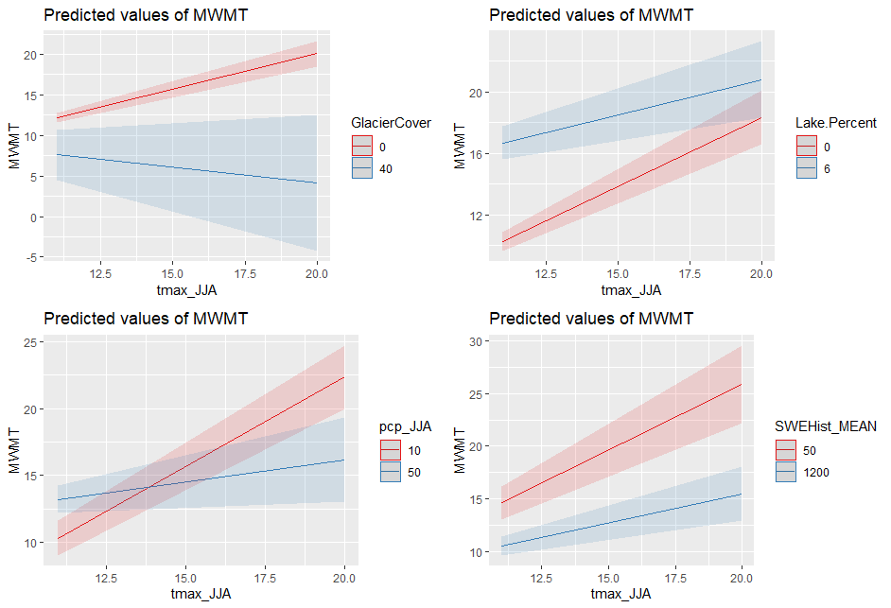
Figure S.X. Modeled interaction effects of Tmax-JJA and glacier cover, lake cover, precipitation, and SWE. Values of Tmax-JJA range from the minimum during monitored years to the maximum value used in future projections. Ranges for interacting variables also represent the range of current and projected values in monitored and all coastal watersheds.

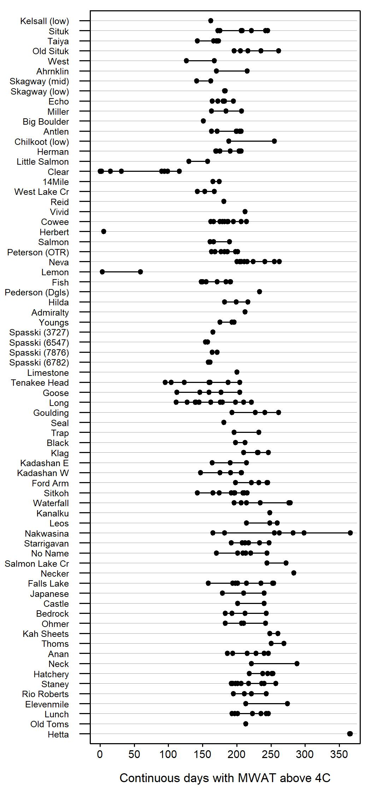
Figure X. Productive season length across sites and years. Sites are plotted north (top) to south (bottom). Emil, this is for you. I can plot it like the red-blue blocks like for MWMT. It seemed slightly out of place in this write-up… but I could be convinced to incorporate it.

RECYCLE BIN
Drainage areas upstream of monitoring sites were delineated using the Watershed tool in ArcPro (version) and compared with relevant USGS Hydrologic Units. In a few instances, the boundary areas produced by these methods disagreed (e.g. low gradient, wetland, infrastructure interference), and best judgement was used to delineate the watershed area.

LITERATURE TO GET
Ficklin et al., 2013
Cristea and Burges,
2009 – snowmelt, temps, sensitivity

